# Subsetting Columns - Individuals and State

This document includes the question, the solution, and a breakdown of the code provided in the screenshot.

## Uploaded Screenshot

Below is the screenshot of the task:

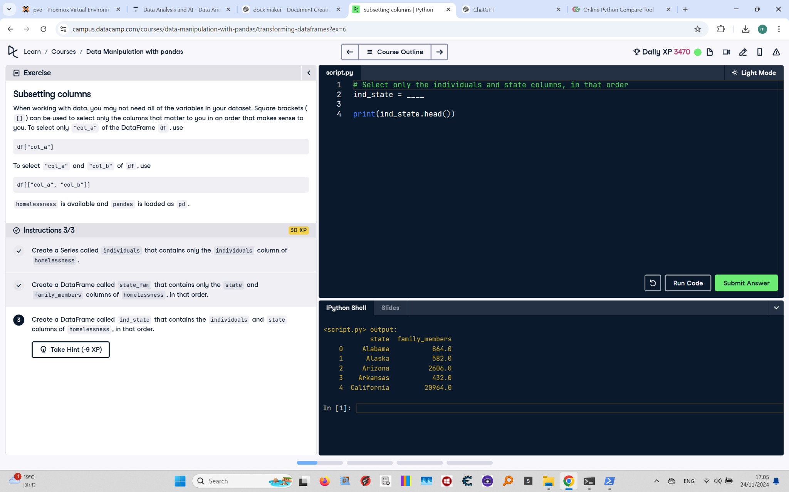

## Question

Create a DataFrame called `ind_state` that contains the `individuals` and `state` columns of homelessness, in that order. Print the first few rows of the DataFrame.

## Answer

# Select only the individuals and state columns, in that order  
ind_state = homelessness[["individuals", "state"]]  
  
# Print the first few rows  
print(ind_state.head())

## Code Explanation

# Explanation of the code:

1. `homelessness[["individuals", "state"]]`: Selects the `individuals` and `state` columns from the `homelessness` DataFrame.

- The double square brackets `[[ ]]` are used to select multiple columns.

2. `ind_state`: Stores the resulting DataFrame with the selected columns.

3. `print(ind_state.head())`: Displays the first five rows of the `ind_state` DataFrame to check its contents.